# Oregon State University EECS Senior Design

Falcon  
An Open Quadrotor Flight System

Joey Tomlinson

Scott Rosenbalm

Torben Rasmussen

Sarah CooleyTable of Contents

Project Introduction 3

Sponsors and Mentors 3

Overview 4

Requirements 4

Existing Solutions 5

Existing MCUs 5

Existing IMUs 5

Solution 7

High Level Design 7

FCU – Flight Control Unit 8

Microcontroller 9

Serial to USB 10

Power Supply 11

IMU – Inertial Measurement Unit 12

Sensors 13

Differential Low Pass Filter and Buffer 14

Testing 15

Power Supply 16

MCU – Motor Control Unit 17

MOSFET Half-Bridge 17

Microprocessor 18

Motors 18

Power Supply 19

System Testing and Validation 20

1khz IMU Update Speed 20

Transfers Data Packets Between Boards 20

Battery Powered 21

External Kill Switch 21

Interfaces with the OSU IARC entry 21

Light Weight 22

Powers the four flight motors 23

Vibration Resistance 23

Wireless Serial Communication 23

Realtime Data Graphing 24

TI Parts Used 25

Appendix I: Schematics 26

FCU Schematic 26

MCU Schematic 27

IMU Schematic 29

Appendix II: PCB Layout 31

FCU Board 31

MCU Board 32

IMU Board 33

Appendix III: Parts List 35

## Project Introduction

### Sponsors and Mentors

Primary:

Revolution Robotics – Aaron Moore

Revolution Robotics – Ben Tribelhorn

Peer Mentors:

Ben Goska

Ryan Albright

Kevin Kemper

The OSU Robotics Club – Aerial Team

Oregon State University – School of EECS

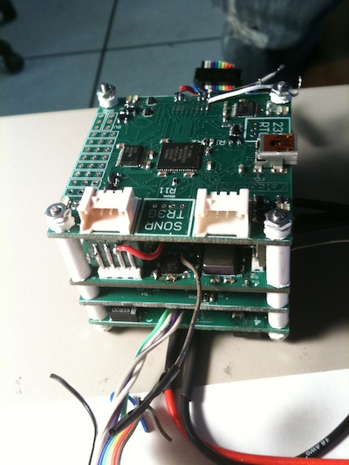

Figure : Flight Control System

### Overview

We created a generic flight control system for quad-rotor aerial vehicles with capabilities specifically engineered to meet the requirements for the OSU Robotics Club's entry in the 2011 International Aerial Robotics Competition (IARC). IARC requires the vehicle navigate indoors, often in close quarters.

To compete, our flight control system will be designed with performance, stability, and versatility in mind. It will employ high bandwidth, high-resolution MEMS sensors and fast control systems in order to maximize stability performance.

Several multi-disciplinary teams are currently working on the IARC quadrotor. We are building the flight control system while other teams build the quadrotor and write the software for autonomous flight (navigation).

However, while our boards are designed with IARC in mind, they will be generic, open source, and available for other quadrotor vehicles.

We will produce three circuit boards and the associated software to form a complete flight control solution. Our three modules will be the:

**The Flight Control Unit** (FCU) integrates input from the Inertial Measurement Unit and output to the Motor Controller Unit. It also interfaces with a master controller (already constructed by OSU Aerial). The main stability control loop runs on this processor at a rate of 1kHz. This board will also provide battery monitoring and emergency stop functionality.

**The Inertial Measurement Unit** (IMU) reads data from MEMS inertial sensors to calculate the angular and lateral motion of the platform. A TI Piccolo processor will process sensor data and provides a state estimate to the FCU every millisecond.

**The Motor Controller Unit** (MCU) controls the speed of the four brushless DC motors that propel and control the quad-rotor. To maximize platform stability, the motor controllers will have a 1kHz update rate and 10 bit resolution. They will drive motors up to 20A at 12V and will be easily modifiable to support higher current and voltage motors.

### Requirements

* The flight control system must interface with the OSU IARC entry
  + Functions normally and continuously between 9 and 12.7 Volts
  + Uses SPI (serial) communication between boards to Communicate with Gumstix Computer
  + Code should be documented and maintainable
* Proper safety precautions should be observed in hardware and software.
  + Remotely activated kill switch.
  + Fail states for unexpected conditions. The controller should decelerate under unanticipated conditions.
* The flight control system should weight less than 300 grams to improve overall efficiency and battery life.
* Our solution must be able to keep the vehicle in flight
  + Powers four flight motors
  + Stable control over the 2kg quadrotor platform
* The vehicle must be aware of its state. Location, battery condition, linear and rotational acceleration, and motor speed data should always be available.
* The vehicle should follow the inputted flight path. Our solution must collect a robust set of environmental and position data.
* Remain within our $1000 budget.

### Existing Solutions

Before designing a flight control system from scratch, we researched existing systems and discovered most packages are prohibitively expensive or use slow, inaccurate, sensors. Our design encompasses the inertial measurement unit and the motor controller. Most existing solutions sell each component separately and we would still need to create the flight control unit to join each system.

Specific Product Requirements:

* 20A BLDC motor controllers x 4 motors
* 3 Axis Accelerometers, Gyroscopes, and Magneto Sensors
* 1khz System Update Rate

#### Existing MCUs

|  |  |  |  |  |  |  |  |  |
| --- | --- | --- | --- | --- | --- | --- | --- | --- |
|  | Current | Voltage | Update Rate | Interface | Weight | Battery Monitor | Over Current | Price |
| Mikrokopter BLDC | 20A | 9-14V | 500Hz | Serial, I2C, PMW | 10g | Yes | Yes | $50 |
| Castle Creations Phoenix-25 | 25A | 9-13V | 50Hz | RC PPM | 17g | Yes | Yes | $80 |
| Volcano-30 | 30A | 5-17V | 50Hz | RC PPM | 25g | No | No | $13 |

Table : Commercial MCU Specifications

Mikrokopter BLDC Motor Controller:

This motor controller is open source and specifically designed for fast update brushless DC motors on the mikrokopter quadrotor platform.

Pros: Fast Update Rate, Lightweight, Multiple Interfaces

Cons: Expensive, Poor documentation

Castle Creations Phoenix-25:

These are commercially available motor controllers designed for remote control aircraft applications.

Pros: Lightweight

Cons: Expensive, Slow Update Rate, Only One Interface

Volcano-30:

Commercially available motor controller designed for hobby remote control aircraft applications.

Pros: Inexpensive

Cons: Slow Update Rate, Only One Interface

#### Existing IMUs

|  |  |  |  |  |  |  |  |  |
| --- | --- | --- | --- | --- | --- | --- | --- | --- |
|  | Acc Range | Acc Noise | Gyro Range | Gyro Noise | Update Rate | Interface | Power | Price |
| xSens MTi | ±5.1g | 204Hz | ±300 d/s | .05Hz | 120Hz | RS232 RS485 RS422 | 350mW | ?? |
| MicroStrain 3DM-GX2 | ±5.0g | ?? | ±300 d/s | .1Hz | 100Hz | RS232 | 90mA @ 5V | $1700 |
| Sparkfun 6DOF Razor | ±3g | 150Hz | ±300 d/s | .035Hz | 50Hz | Analog | ?? | $90 |
| Sparkfun 6DOF v4 | ±6g | 350Hz | ±500 d/s | .4Hz | 100Hz | RS232 Bluetooth | 150mA @ 5V | $450 |

Table : Commercial IMU Specifications

xSens MTi:

Commercially available IMU meant for industrial and robotics applications.

Pros: Low Power, Low Noise

Cons: Slow Update Rate, Limited Interface Options, Expensive

MicroStrain 3DM-GX2:

This is a commercially available IMU meant to control aircraft attitude and heading reference.

Pros: Low Noise, Low Power

Cons: Slow Update Rate, Expensive

Sparkfun 6DOF Razor IMU:

Hobbyist IMU meant for general-purpose motion sensing applications.

Pros: Inexpensive, Light Weight

Cons: Slow Update Rate, Only One Interface, Small Sensor Ranges

Sparkfun 6DOF v4 IMU:

High quality hobbyist IMU meant for general-purpose motion sensing applications.

Pros: Light Weight, Good Sensor Ranges, Multiple Interfaces

Cons: Expensive, Noisy Sensors

Considering our requirements, none of the currently available IMU/MCU combined solutions would be acceptable solutions. In most cases we would need to purchase 4 MCUs, 1 MCU then build the flight controller main board. Even with a larger budget, the pre-built solutions are too expensive.

## Solution

We broke out flight control solution into three major blocks. Each block is on a different circuit board and operates independently of the other blocks. Each communicates through serial with well-defined and documented data packets. We chose this board breakdown since flight controllers are generally sold as an IMU and motor controller.

### High Level Design

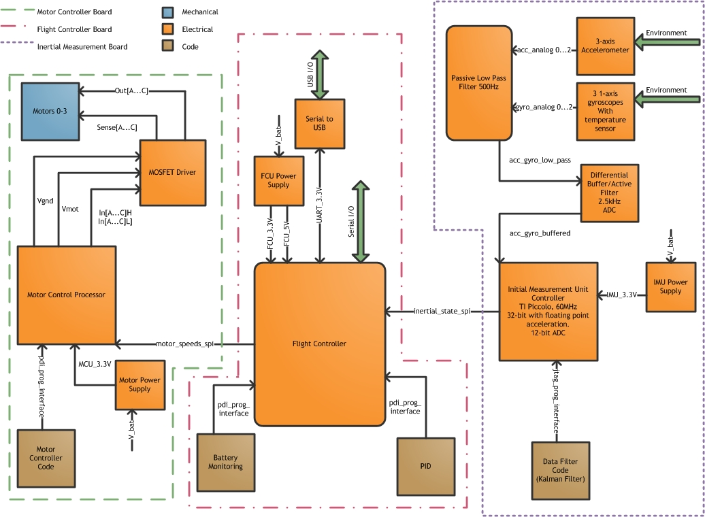

Figure : System Block Diagram

|  |  |  |
| --- | --- | --- |
| Name | Type | Specification |
| V_3.3V | Electrical | 3.3V DC nominal +- .3V |
| 3_phase_ac | Electrical | 12V 20A max |
| pdi_prog_interface | Control |  |
| jtag_prog_interface | Control |  |
| serial | Communication | 3.3V 8n1 Serial |
| gyro_analog | Electrical | 300dps 2% Temp drift |
| acc_analog | Electrical |  |
| Battery | Power | 9-12.8V, 100A Li-poly |
| Power Switch | User Interface | SPDT |
| Motor Enable Switch | User Interface | SPDT, Must not falsely activate under vibration |

Table : Top Level Interface Definition

## FCU – Flight Control Unit

The FCU, outlined in red in the center of Figure 1, integrates input from the Inertial Measurement Unit and outputs motor speeds to the Motor Controller Unit. It also interfaces with a master controller (already constructed by OSU Aerial).

In software, the main stability control loop runs on this processor at a rate of 1kHz. The board interfaces with a computer using serial over USB and using Xbee wireless serial communication. The FCU provides a console based control mechanism and battery monitoring. From the monitoring computer, a user can control motor speeds and emergency stop functionality.

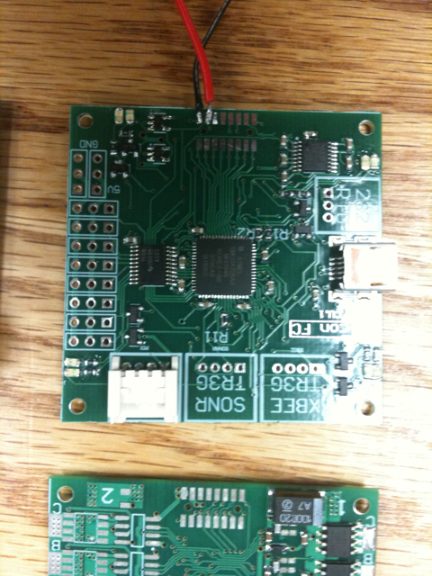

Figure : Flight Control Board

### Microcontroller

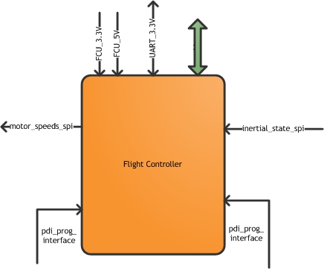

Figure : FCU Controller Block

|  |  |  |
| --- | --- | --- |
| Name | Type | Specification |
| Vbat | Electrical Input | 16.4V (Max) |
| 3.3V | Electrical Output | 3.3V, 50A Max |
| 5V | Electrical Output | 5V, 50A Max |
| rc_5_n | Electrical Input | 5V PWM |
| Sonar | Electrical Input/Output | 3.3V UART |
| Xbee | Electrical Input/Output | 3.3V UART |
| rs422 | Electrical Input/Output | RS-422 Serial |
| MISO/MOSI | Electrical Input/Output | 3.3V SPI |
| SCK | Electrical Output | 3.3V Clock |
| MOT_EN | Electrical Output | 3.3V Motor Enable signal |
| SSn | Electrical Output | SPI Chip select signals |

Table : FCU Controller Interface Definition

The microcontroller is the most important aspect of the FCU since it handles battery monitoring, some basic filtering, and serial behavior controls as well as outputting voltages for the motor controller and interfacing the boards. Specifically, the central flight control unit (fcu) is responsible for communicating between the imu, mcu, and a number of external peripherals. The on-board xmega128a3 reads in filtered digital sensor data from the imu over SPI, and runs a PID control loop to determine the necessary motor speed targets. It then relays this information over SPI to the motor control unit. Also, this processor will be responsible for communicating with external computers (onboard or off) to update PID settings, receive high level commands, or receive control input. This is accomplished with two serial protocols, RS-422, and 3.3V serial to USB.

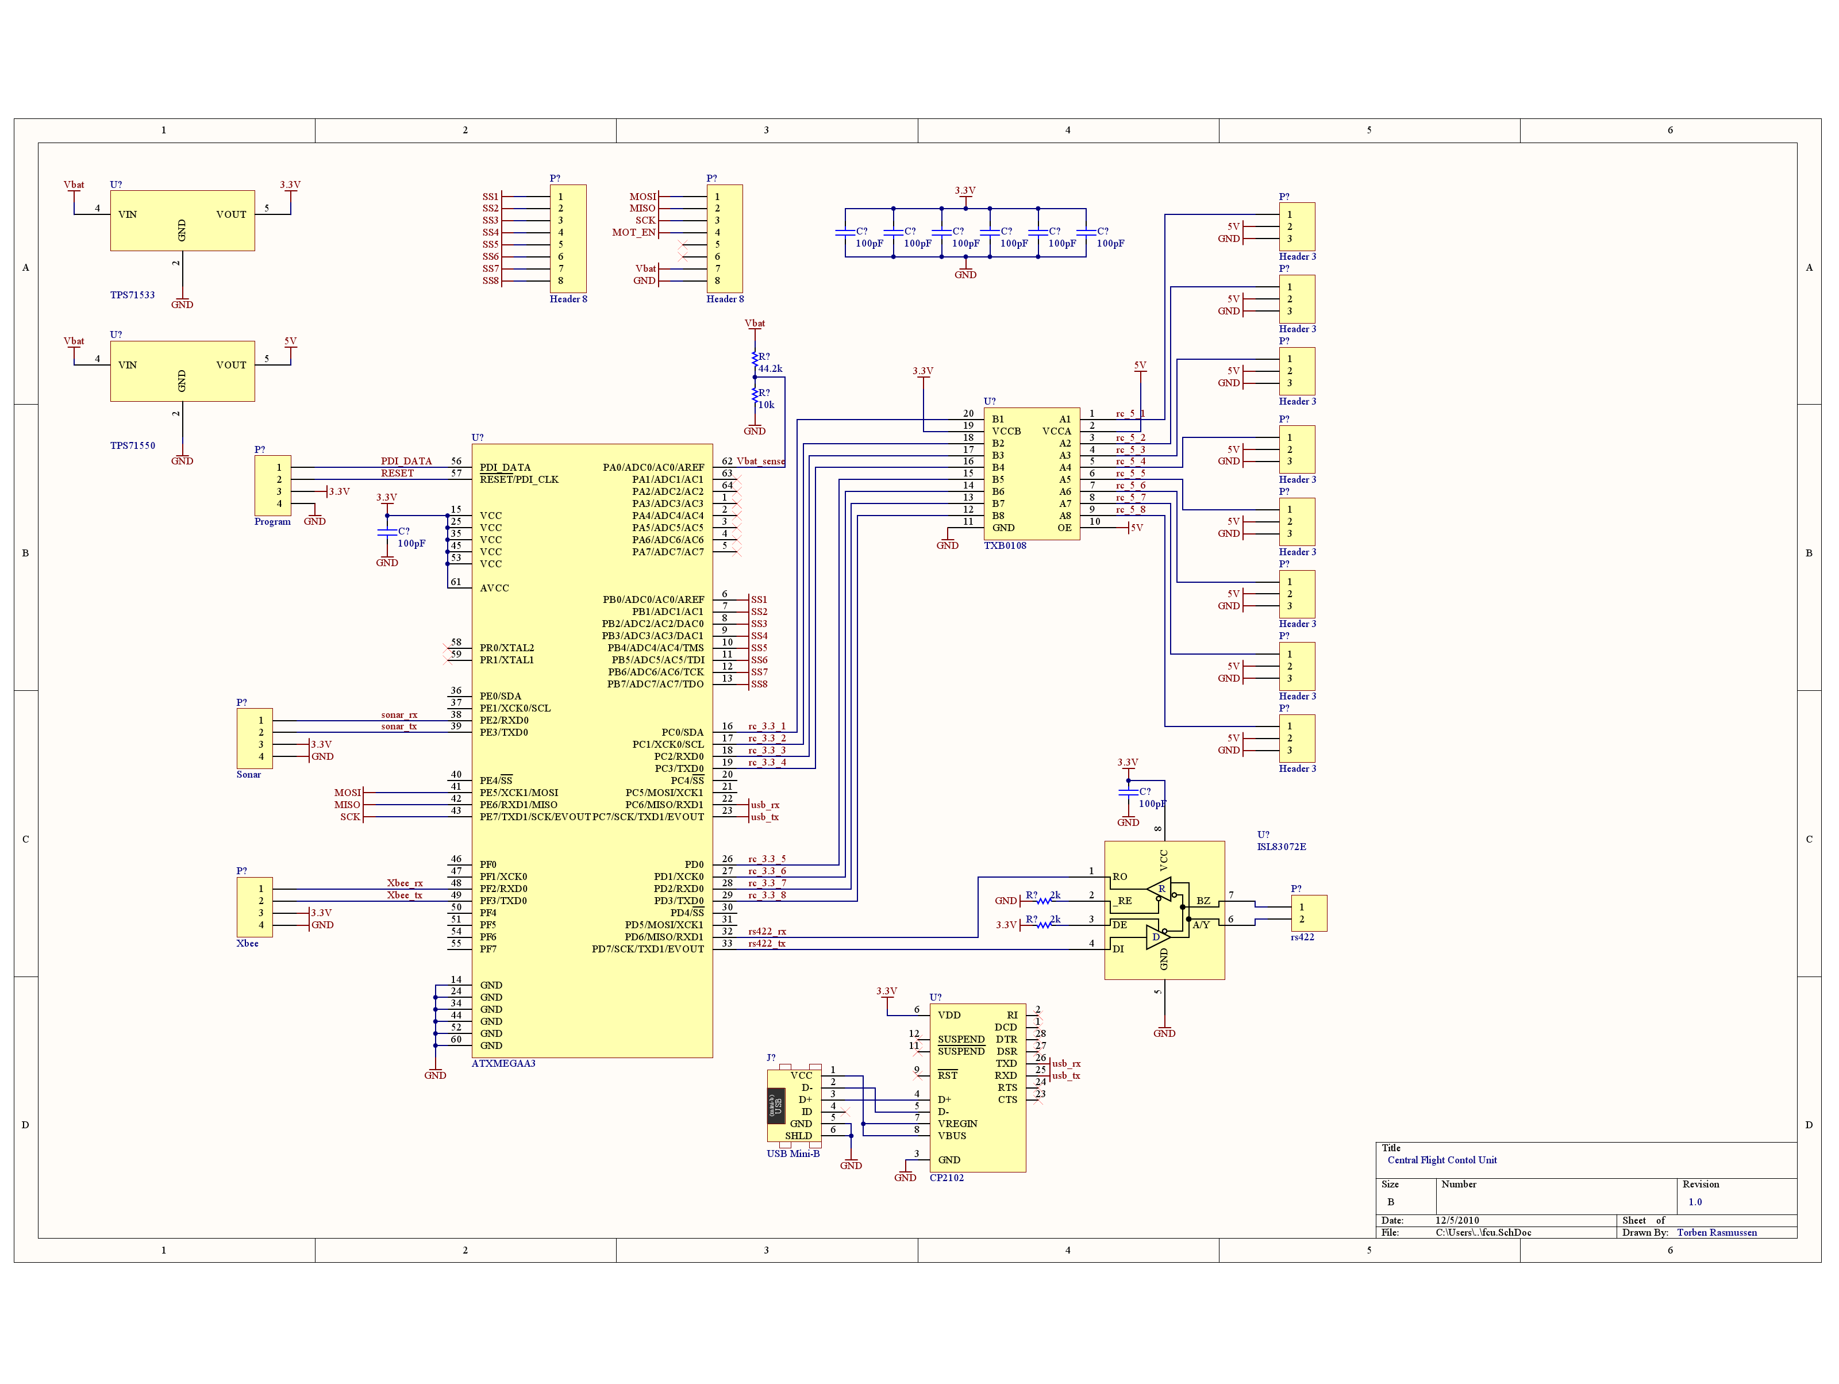

Figure : Flight Controller Schematic

The voltage divider used to measure battery voltage must reduce the voltage to below 3.3V for safe operation.

The maximum voltage of a 4-cell Li-Poly battery pack is 4.1V * 4 cells = 16.4V.

V(adc0_max) = 16.4V * (10k / (44.2k + 10k)) = 3.0258V < 3.3V.

Worst case with 1% resistors:

V(adc0_max) = 16.4V * (10.1k / (39.78k + 10.1k)) = 3.3V

All other components are designed to work in low-power situations at either 3.3V or 5V and do not exceed any of the absolute maximum ratings in the Xmega a3 microcontroller datasheet.

### Serial to USB

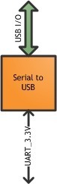

Figure : Serial to USB Block

|  |  |  |
| --- | --- | --- |
| Name | Type | Specification |
| UART_3.3V | Electrical Input/Output | 3.3V Serial |
| USB I/O | Electrical Input/Output | USB |

Table : Serial to USB Interface Definition

This device is responsible for converting 3.3V asynchronous serial signals to USB. This will be one of the main ways the central flight controller interfaces with external computers.

The 3.3V serial interface is within tolerances for the chip. The power requirements of the chip are met by the 3.3V power supply on the flight control board.

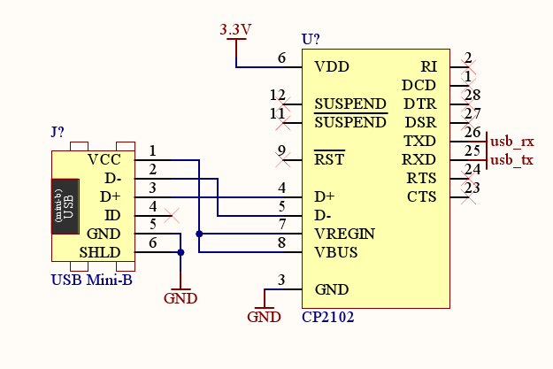

Figure : Serial to USB Schematic

### Power Supply

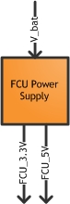

Figure : FCU Power Supply Block

|  |  |  |
| --- | --- | --- |
| Name | Type | Specification |
| V_bat | Electrical Input | 9-12.6V |
| FCU_3.3V | Electrical Output | 3.3V, 50A max |
| FCU_5V | Electrical Output | 5V, 50A max |
| V_bat | Electrical Input | 9-12.6V |

Table : FCU Power Supply Interface Definition

This block is responsible for providing power to the central flight control unit and its peripherals at both 5 and 3.3V. The linear voltage regulator chips are designed to output 50mA. The total current draw of all parts at each voltage level will not exceed 25mA.

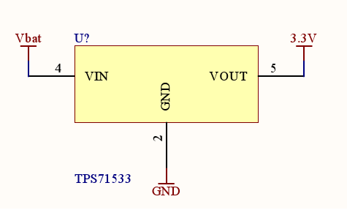 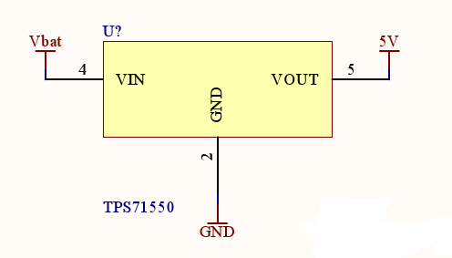

Figure : FCU Power Supply Schematic

## IMU – Inertial Measurement Unit

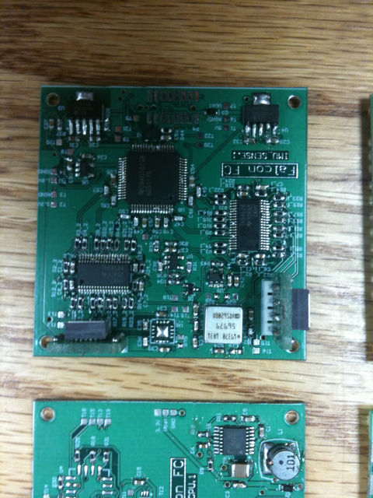

Figure : IMU Sensor Board

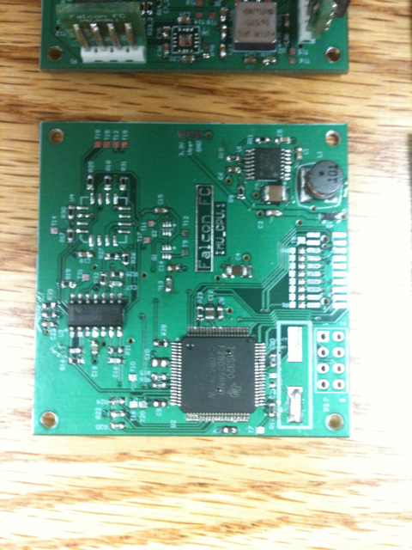

Figure : IMU CPU Board

### Sensors

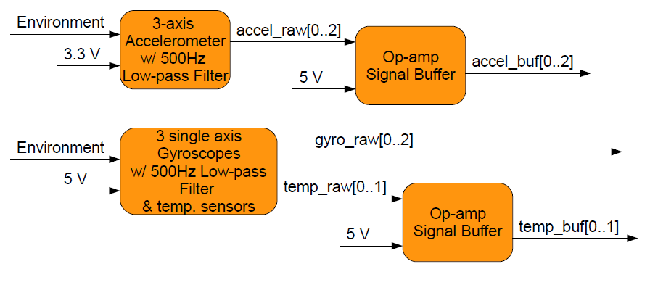

Figure : Sensor Block

|  |  |  |
| --- | --- | --- |
| Name | Type | Specification |
| 5V | Electrical Input | 5V power supply. |
| 3.3V | Electrical Input | 3.3V power supply. |
| accel_raw[0...2] | Electrical Signal | Analog outputs from accelerometer. Signal between 0V - 3.3V and has been through passive 500Hz low-pass filter. Un-buffered |
| accel_buf[0...2] | Electrical Output | Buffered analog outputs from accelerometer. Signal between 0V - 3.3V. |
| gyro_raw[0...2] | Electrical Output | Analog outputs from gyros. Signal between 0V - 5V and has been through passive 500Hz low-pass filter. |
| temp_raw[0...1] | Electrical Output | Analog temperature outputs from pitch and yaw gyros, un-buffered. Signal between 0V - 5V. |
| temp_buf[0...1] | Electrical Output | Buffered analog temperature outputs from pitch and yaw gyros. Signal between 0V - 5V. |

Table : Sensor Interface Definition

All sensor data is low-pass filtered by applying capacitors to certain pins on the sensor IC. The bandwidth was set to 500 Hz for all sensors to remove aliasing in the signal when sampling at 1kHz, according to Nyquist sampling theory.

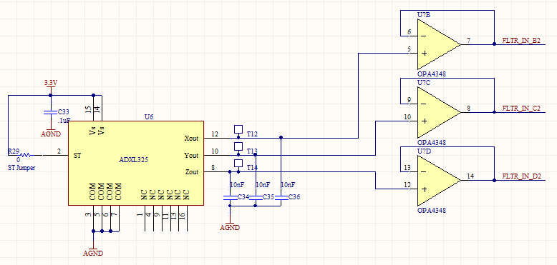

Figure : Accelerometer Schematic

For the accelerometers, bandwidth is set by the equation f = 1/(2π(32 kΩ) × C), resulting in a capacitance of 10nF for each axis output.

Range: +/-5g max acceleration

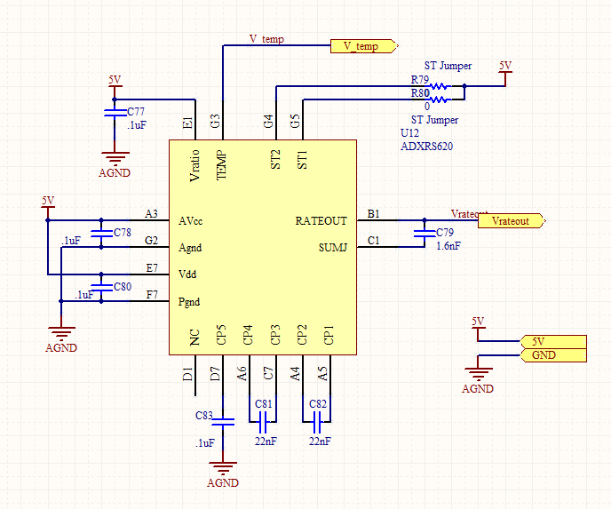

Figure : Gyroscope Schematic

For the gyroscopes, bandwidth is set by the equation f = 1/(2π(180 kΩ) × C), resulting in a capacitance of 1.6nF for each gyro output.

Range: +/- 250dps

### Differential Low Pass Filter and Buffer

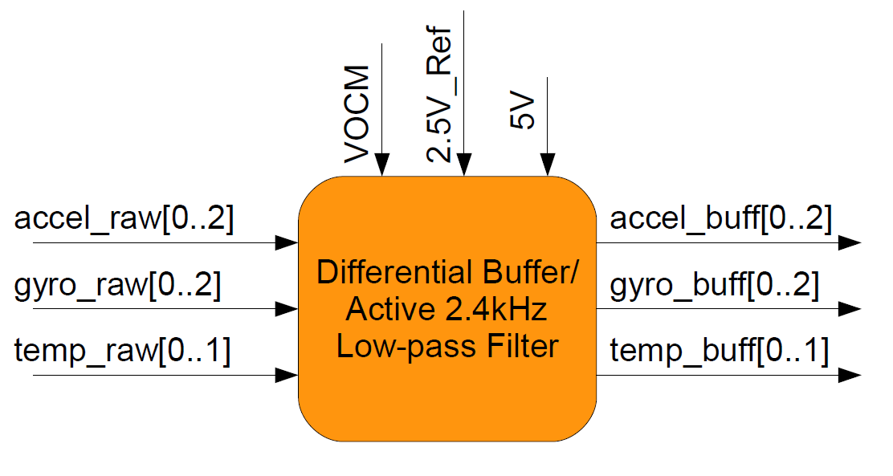

Figure : Differential Buffer Block

|  |  |  |
| --- | --- | --- |
| Name | Type | Specification |
| accel_raw[0...2] | Electrical Input | Analog outputs from accelerometer. Signal between 0V - 3.3V and has been through passive 500Hz low-pass filter. |
| gyro_raw[0...2] | Electrical Input | Analog outputs from gyros. Signal between 0V - 5V and has been through passive 500Hz low-pass filter. |
| temp_raw[0...1] | Electrical Input | Analog temperature outputs from pitch and yaw gyros. Signal between 0V - 5V. |
| VOCM | Electrical Input | Buffered 2.5V reference. |
| 2.5V_Ref | Electrical Input | 2.5V reference voltage from zener diode. |
| 5V | Electrical Input | 5V power supply. |
| accel_buff[0...2] | Electrical Output | Buffered differential pairs of accelerometer data. Signal centered at 2.5V and swings +- 2.5V. Low-pass filtered at 500Hz and 2.4kHz. |
| gyro_buff[0...2] | Electrical Output | Buffered differential pairs of gyro data. Signal centered at 2.5V and swings +- 2.5V. Low-pass filtered at 500Hz and 2.4kHz. |
| temp_buff[0...1] | Electrical Output | Buffered differential pairs of temperature data. Signal centered at 2.5V and swings +- 2.5V. Low-pass filtered at 2.4kHz. |

Table : Differential Buffer Interface Definition

A 500Hz passive low-pass filter is pre-applied to all the analog sensor outputs. To further reduce the noise produced by some of the sensor's resonant frequencies (at around 14kHz), this 2.4kHz active low-pass filter is applied to each signal. The frequency of the active filter is determined by the equation f = 1/(2*pi*R*C), where R and C are in parallel across the output and input of the op-amp. With the chosen values, a 2.4kHz low-pass filter is achieved. Differential op-amps were used because the ADC has differential inputs that should be driven differentially to achieve the best performance. See schematic below.

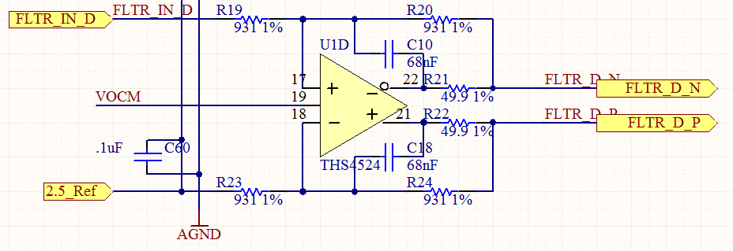

Figure : Differential Buffer Schematic

#### Testing

Apply a 200hz, 1v pk-pk ac signal to the analog inputs. 200Hz is a low enough frequency it should not be filtered. Scope the output signal. The amplitude must be at least 90% of the input amplitude.

Below is an image of an oscilloscope measuring the input and outputs of the buffer/filter block. For this test, a 200Hz 1V pk-pk sine wave (yellow wave, top) was applied to the input of the buffer/filter block. Since the op-amp is differential (and I did not want to short output to ground through the ground of the other probe) I measured the positive (blue wave, middle) and negative (purple wave, bottom) outputs separately, then used the math function to plot positive minus negative (red wave, middle). The image also shows calculations on the right side of the screen. The input amplitude was 0.96V, while the output amplitude was 0.98V. The output amplitude is greater than 90% of the input amplitude therefore the test is passed.

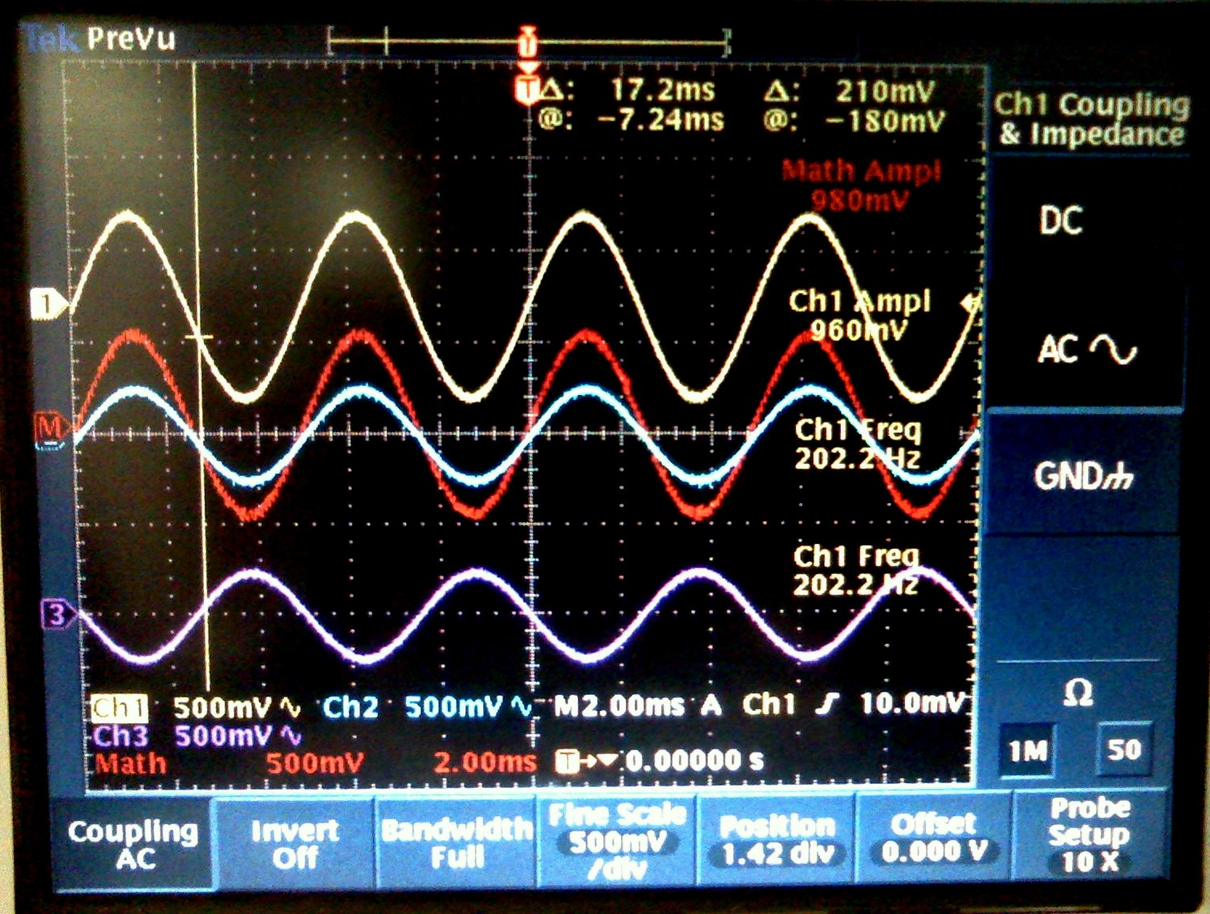

Figure : Buffer Passes Low Frequencies Check

Apply a 10kHz, 1v pk-pk ac signal to the analog inputs. 10kHz is a high enough frequency it should be filtered. Scope the output signal. The amplitude out must be less than 50% of the input amplitude.

Below is an image of an oscilloscope measuring the input and outputs of the buffer/filter block. For this test, a 10kHz 1V pk-pk sine wave (large yellow wave in the image) was applied to the input of the buffer/filter block. The positive and negative outputs of the differential op-amp were measured separately, and then subtracted to obtain the full output signal. The output signal is shown in red. The calculations on the right side of the screen show that the input amplitude was 0.956V and the output amplitude was 0.24V. The output amplitude is less than 50% of the input amplitude therefore the test is passed.

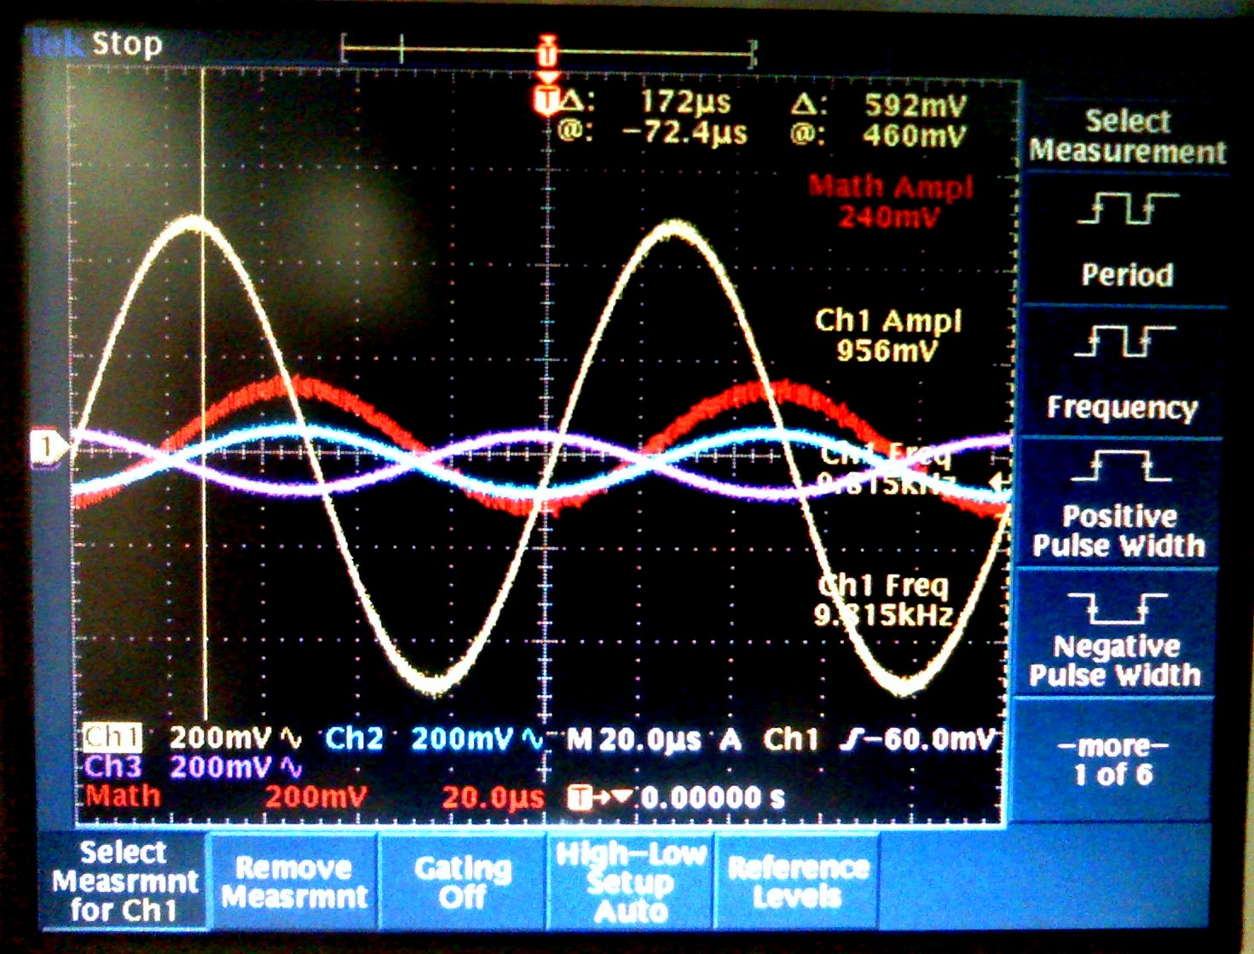

Figure : Buffer Filters High Frequencies Check

### Power Supply

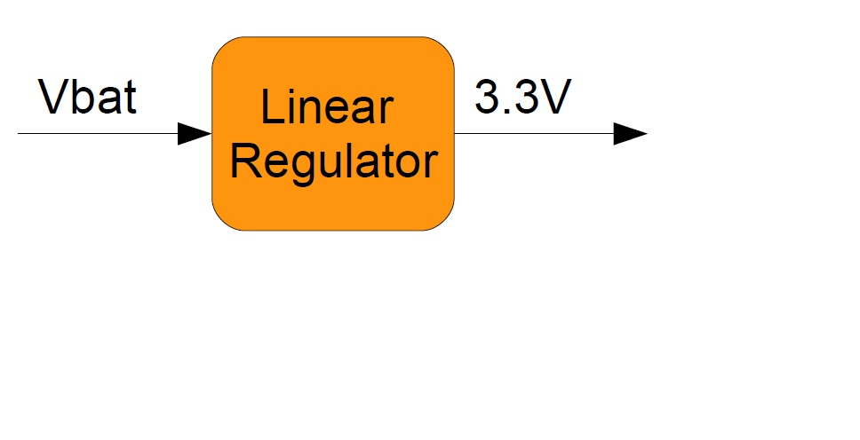

Figure : IMU Power Supply Block

|  |  |  |
| --- | --- | --- |
| Name | Type | Specification |
| V_bat | Electrical Input | Power Input From Battery 9V-16V, 12V nominal. |
| 3.3V | Electrical Output | 3.3V Power Output for IMU_CPU board. 200mA output |

Table : IMU Power Interface Definition

This is a simple linear regulator from TI. It has a maximum output current of 500mA, but our system should only need ~100mA.

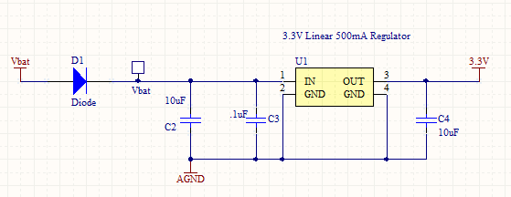

Figure : IMU Power Supply Schematic

## MCU – Motor Control Unit

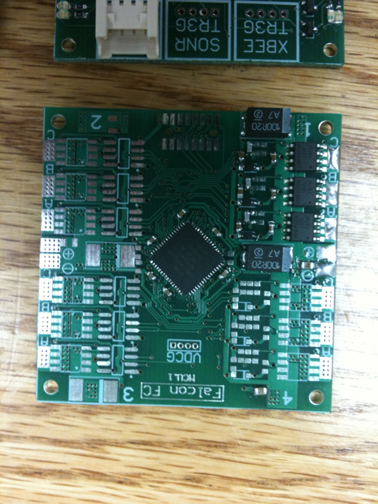

Figure : MCU Board

### MOSFET Half-Bridge

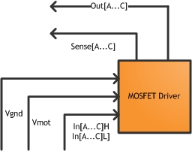

Figure : MOSFET Half-Bridge Block

|  |  |  |
| --- | --- | --- |
| Name | Type | Specification |
| Vmot | Electrical Input | Motor Power Input |
| Vgnd | Electrical Input | Motor Power Input |
| In[A..C]H | Electrical Input | 3.3V Pulse Width Modulation, High side FETs |
| In[A..C]L | Electrical Input | 3.3V Pulse Width Modulation, Low side FETs |
| Out[A..C] | Electrical Output | Power Output To Motors |
| Sense[A..C] | Electrical Output | 0-3.3V Analog Feedback From Motor Coils |

Table : MOSFET Half-Bridge Interface Definition

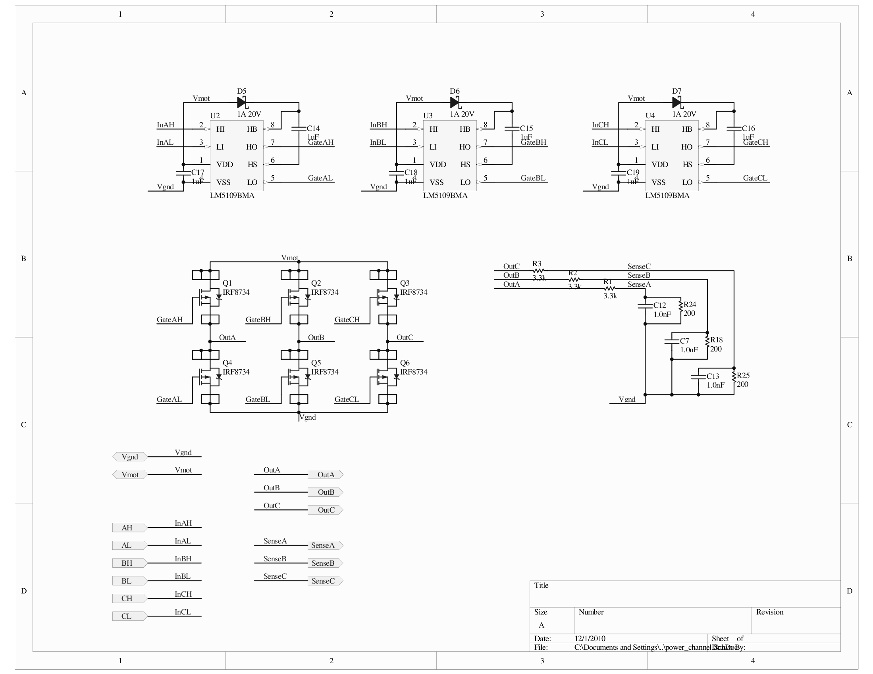

Figure : MOSFET Half-Bridge Schematic

MOSFET Validation

Vds(max) = 30V, Id(max) @ 70 Degrees C = 17A, Rds(on) = 3.5mOhms, Pdiss(max) @ 70 Degrees C = 1.6W

At out 15A max motor current, Pdiss = I2*R = 152*(3.5x10-3) = 0.7875W

MOSFET Driver Validation

Imax = 1A, Vdd = 8V to 14V, I/O threshold = 0.8V(low)-2.2V(high)

Sense Voltage Divider Validation

Vout = Vin(R2/Rtotal) = 12.6(200/3.5e3) = 0.72V max Sense Voltage

### Microprocessor

### Motors

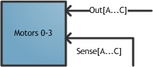

Figure : Motors Block

|  |  |  |
| --- | --- | --- |
| Name | Type | Specification |
| Sense[A..C] | Electrical Output | 0-3.3V Analog Feedback From Motor Coils for Back EMF Sensing |
| Out[A..C] | Electrical Input | Power Input To Motors |

Table : Motor Block Interface Definition

Motors were selected in previous years. In order to maintain level flight, the motors had to lift and accelerate the 2kg quadrotor with relative ease. It was determined that 15A at 9V should be more than enough to power the quadrotor. The motors were also selected based on availability; the motors chosen are commonly used by hobbyists and easily replaceable.

### Power Supply

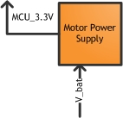

Figure : Motor Power Block

|  |  |  |
| --- | --- | --- |
| Name | Type | Specification |
| V_bat | Electrical Input | 9-12.6V, 20mA max |
| MCU_3.3V | Electrical Output | 3.3V, 20mA max |

Table : Motor Power Interface Definition

The linear voltage regulator chips are designed to output 50mA. The total current draw of all parts at each voltage level will not exceed 20mA. With this in mind, our voltage regulators should be more than adequate.



Figure : Motor Power Schematic

## System Testing and Validation

### 1khz IMU Update Speed

The IMU needs to provide an inertial state estimate at a rate high enough to allow the vehicle to be as stable as possible. This is important because excess platform vibrations negatively influence the camera and lidar sensors.

The IMU must provide an inertial state estimate once every millisecond.

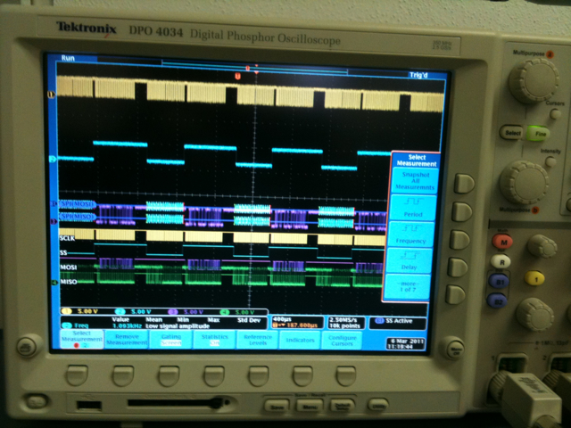

Figure : Oscilloscope Data and Refresh Rate

### Transfers Data Packets Between Boards

Data must be accurate to maintain a stable platform. FCU receives data packets from the IMU and MCU. IMU transfers roll, pitch, yaw. MCU transfers motor speeds. Data streams to the FCU through spi and values make sense.

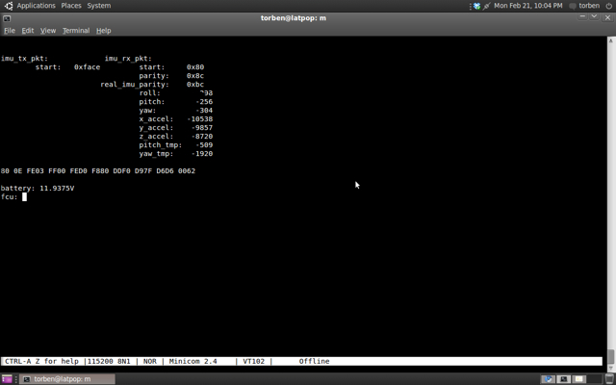

Figure : IMU Data with SPI

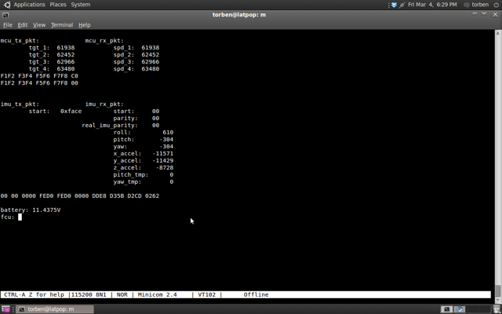

Figure : MCU Data with SPI

### Battery Powered

The flight control system continues operating smoothly between 9 and 13 volts. Voltage provided by a power supply so we could easily modify the voltage.

See the video: <http://beaversource.oregonstate.edu/projects/44x201007/attachment/wiki/TestEvidence/IMG_0524.mov>

### External Kill Switch

The flight controller must include a fail-safe kill switch. In our case, the flight controller must accept a wireless signal that causes all motors to be disabled upon activation.

<http://web.engr.oregonstate.edu/~cooleys/kill_switch.MOV>

### Interfaces with the OSU IARC entry

Our flight control system must interface with the vehicle's main computer. The flight control unit (FCU) uses a serial over usb to interface to the master computer on the OSU IARC entry. See Data Packets Transferred test for serial over USB data.

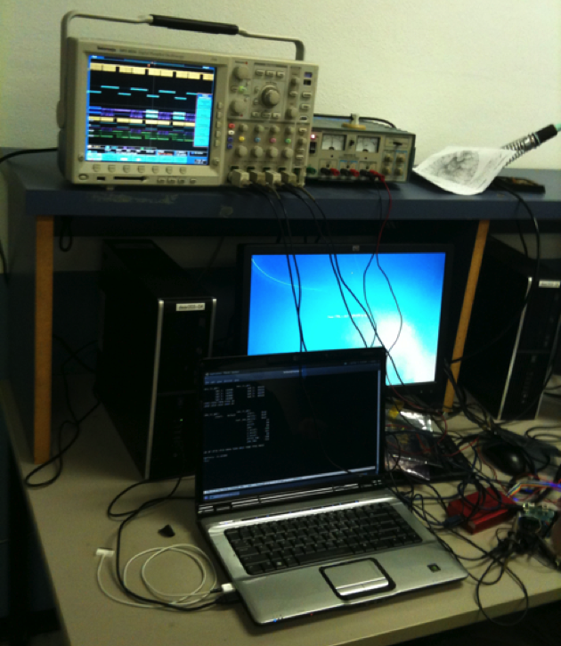

Figure : Lab Setup with USB

### Light Weight

The OSU IARC team needs the flight control system to be as light-weight as possible in order to keep their platform under 1.5kgs. Indeed, the entire flight control system should weight less than 300 grams.

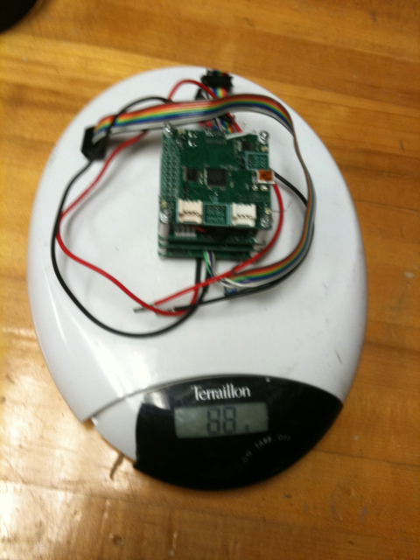

Figure : Weight

### Powers the four flight motors

The IARC submission uses four brushless DC motors. To power these motors, our motor control unit (MCU) should be able to supply a minimum of 15A per motor (60A total).

### Vibration Resistance

All board-to-board connectors should be secured with screws or other similar secure fasteners. Fasteners and spacers hold boards stable and equally spaced. Solder joints hold through handling and testing.



Figure : Board with Fasteners

### Wireless Serial Communication

FCU receives serial data packets wirelessly through an xbee module. Data is transmitted accurately and in a timely manner.

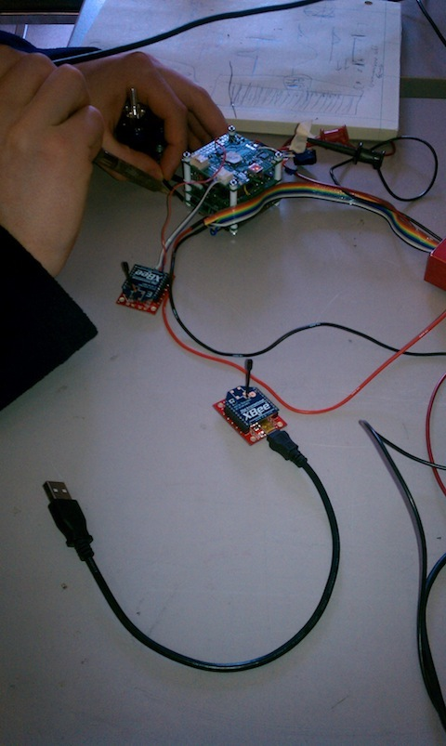

Figure : Wireless with Xbee Modules

### Realtime Data Graphing

Data is graphed as it's received. Graph updates at least one point per second.

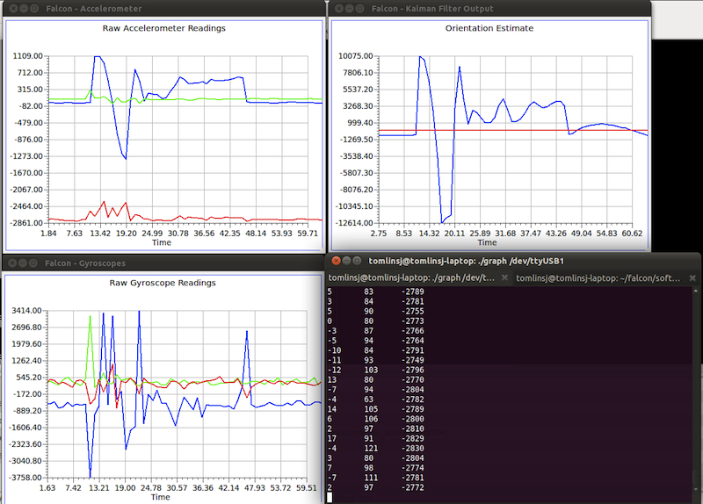

Figure : Realtime Data Graphing

## TI Parts Used

Texas Instruments parts play several essential roles at the core of our inertial measurement unit (IMU) design. All of our sensors are buffered by TI op-amps; the analog inertial sensors are buffered by a rail-to-rail op-amp (OPA4348). Then the signals are fed into a differential op-amp (THS4524). This op-amp setup converts our single-ended sensor signals into differential pairs, centered around 2.5V, as well as providing an active low pass filter. The sensor signals are then fed into an eight-channel delta-sigma analog-to-digital converter (ADS1178). The ADS1178 allows us to simultaneously sample eight channels at rates of up to 52K samples/sec.

High-speed simultaneous sampling is crucial for inertial-based control and platform stability. The ADS1178 was the obvious best choice for our application.

We picked the powerful TMS320F28035 (Piccolo F28035) as our filtering processor to leave a large margin for any computationally complex filtering algorithms we may use. This beast of a processor runs at 60MHz, has 32-bit operations, and has a floating-point co-processor that can do single cycle 32-bit floating point operations while the main processor is busy servicing i/o requests. This revision does not actually use the floating-point coprocessor, but it would be used if we were doing more complex data filtering.

## Appendix I: Schematics

### FCU Schematic



### MCU Schematic

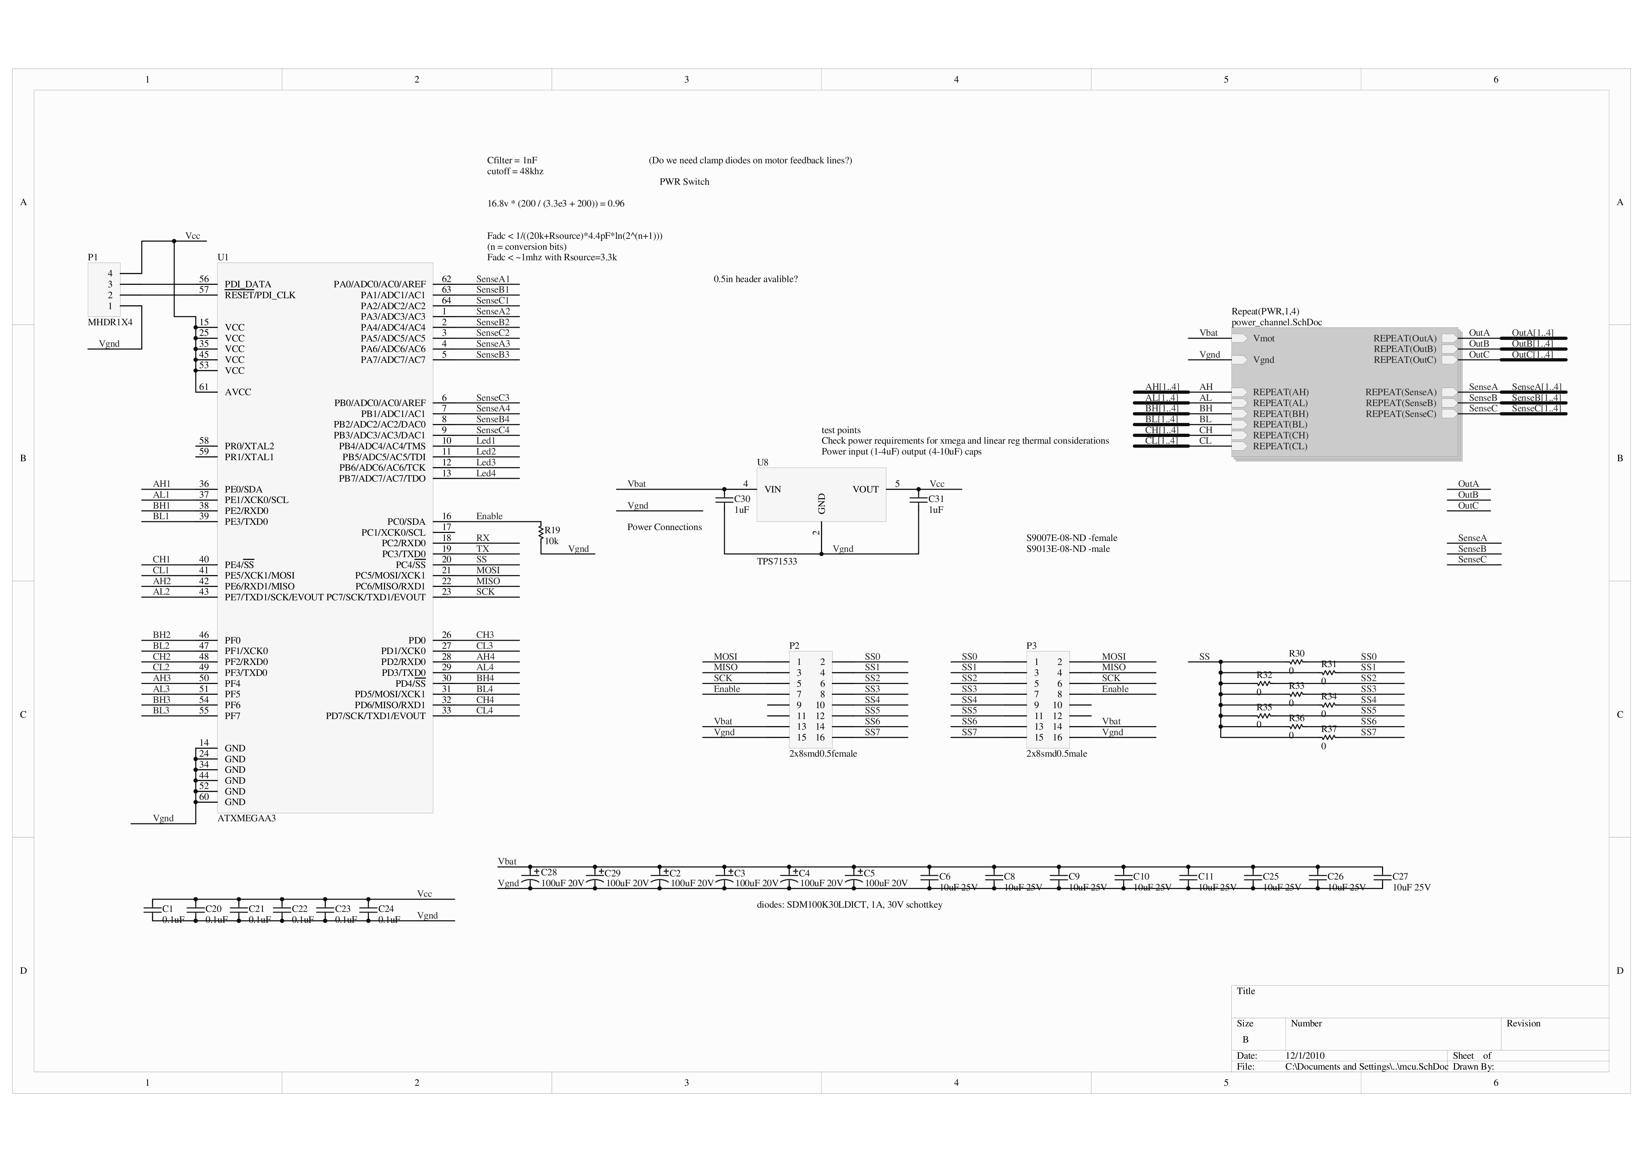



### IMU Schematic

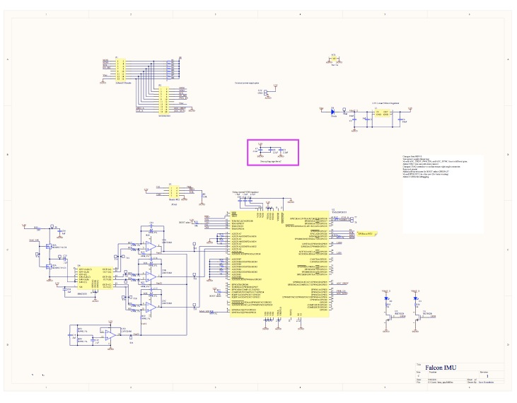

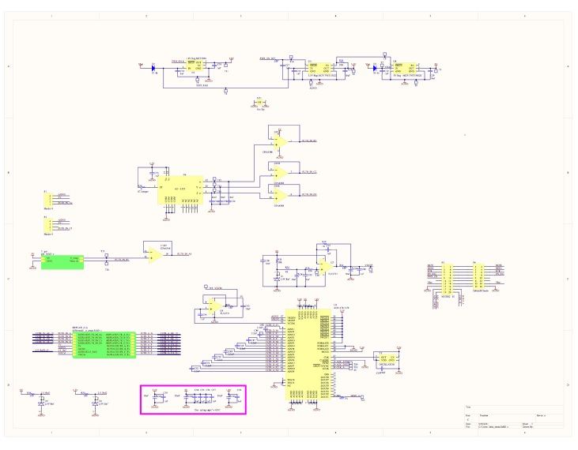

## Appendix II: PCB Layout

### FCU Board

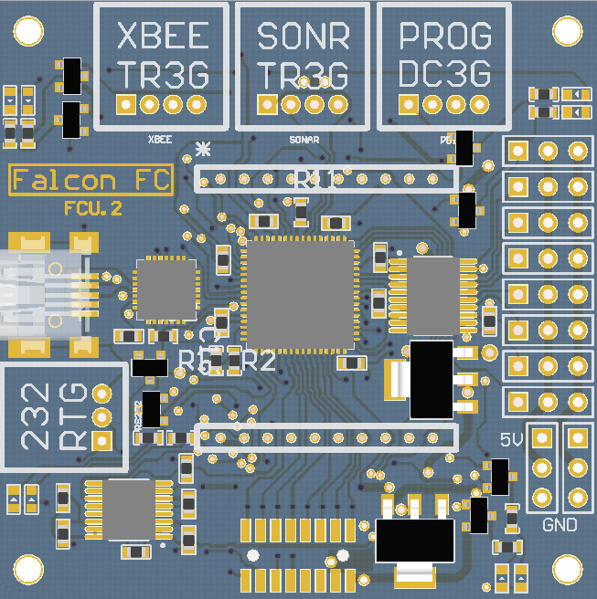

### MCU Board

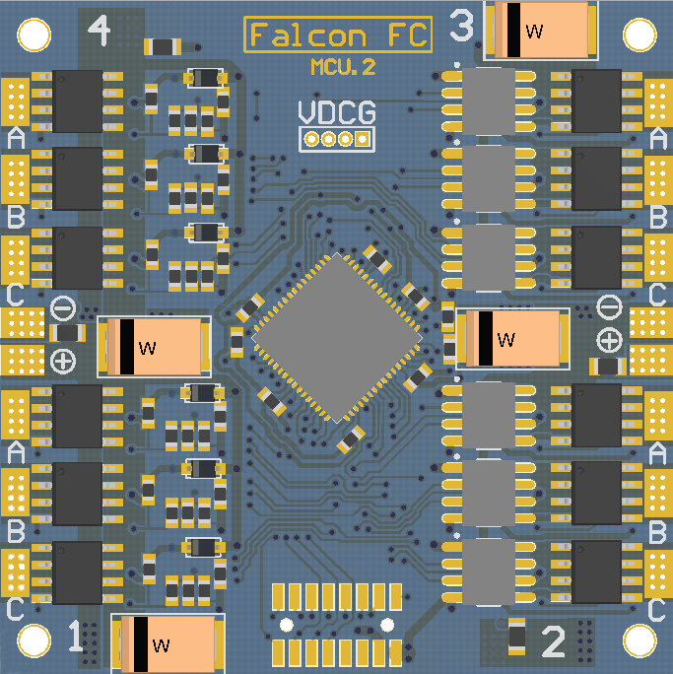

### IMU Board

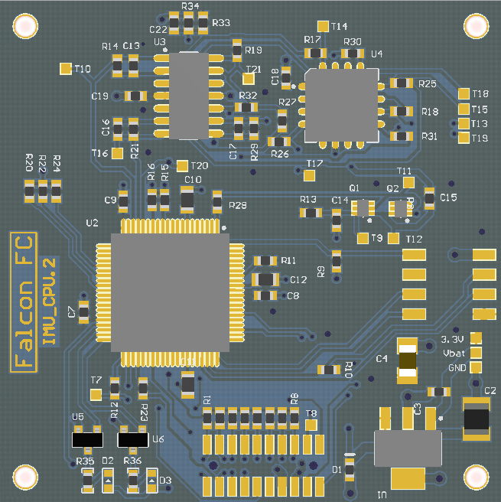

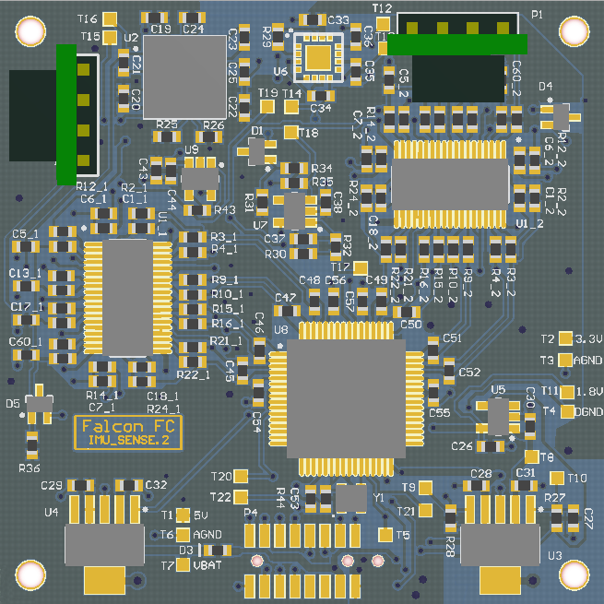

## Appendix III: Parts List